**D&C – dafuq is that?:**

Divide and Conquer is the general idea that if you have a problem, an efficient way of solving it is by dividing it into smaller subproblems, and then solving those one by one instead. It is basically a 3 step method:

**Divide** the problem.

**Conquer** the individual problems.

**Combine** the solutions of all the problem to solve the big combined original problem.



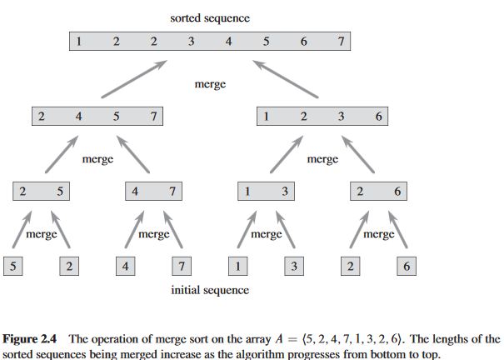 HINT: *Look for the word ‘merge’ in the fucking diagram.*

